CCNA WAN Technologies
A. Introduction to WAN Technologies
1. Create a table comparing at least three types of WAN connections (such as leased line, DSL, and MPLS) with columns for speed, cost, and typical use cases.
=
WAN Type Speed Cost Typical Use Cases
Leased Line 10 Mbps - 10 Gbps + High Large business, dedicated
connectivity.
DSL 1 - 100Mbps Low Homes and small office.

MPLS 10 Mbps - 10 Gbps + High Connecting multiple branch
office.

2. Draw a labeled diagram (on paper or using any drawing tool) showing how a CSU/DSU connects a router to a WAN service provider, and explain the role of each device in 2-3 sentences.
= 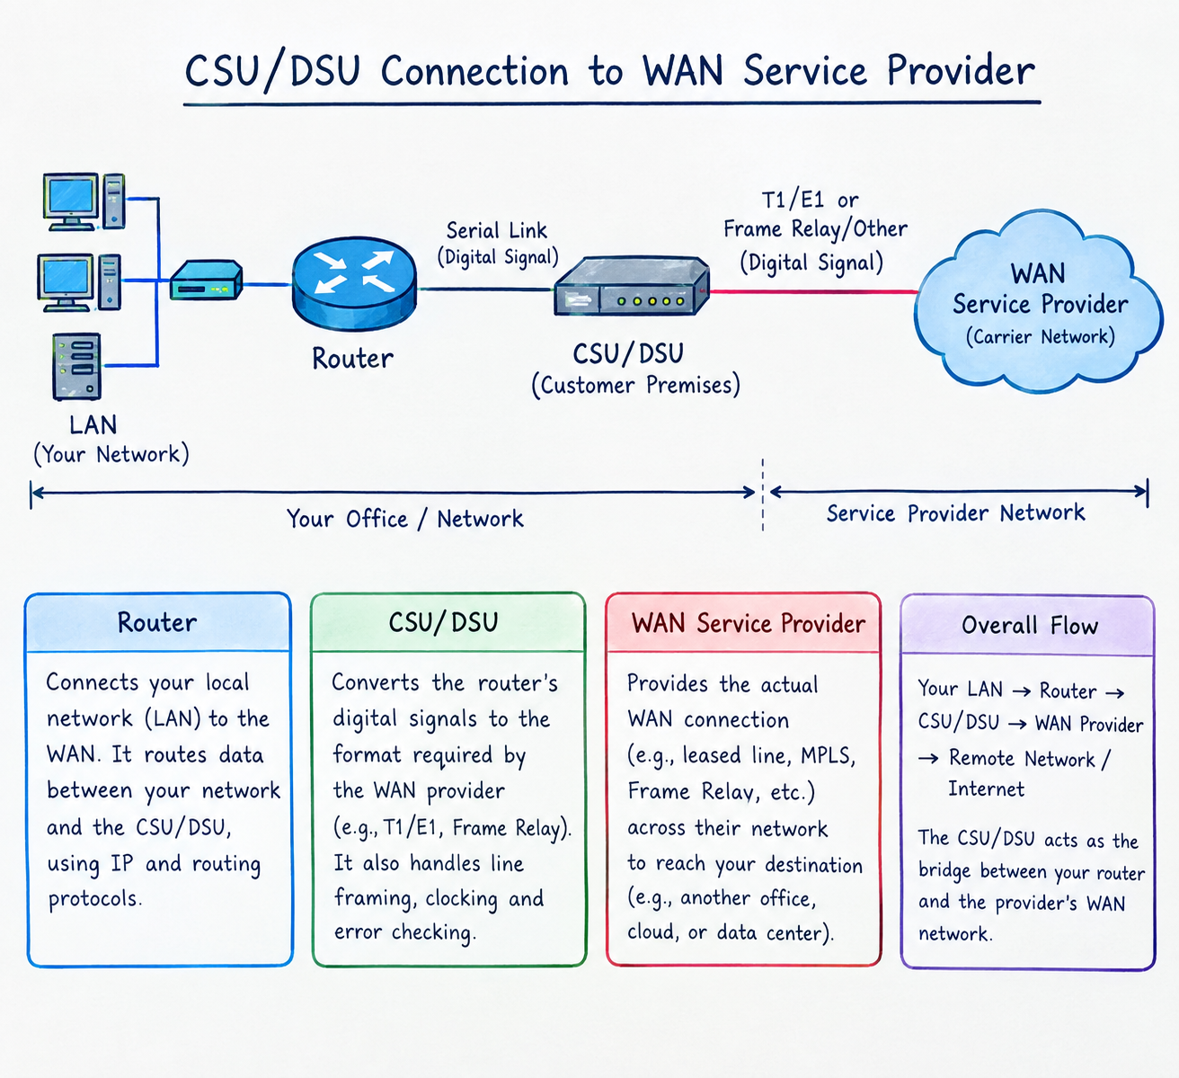
3. List three real-world examples of popular apps or services (like IRCTC, WhatsApp, or Zomato) that rely on WAN connections, and briefly describe how WAN enables their functionality.
=
App/Service | How WAN Enables Its Functionality
IRCTC | Connects users to railway servers over the internet to search trains, check seat availability, and book tickets.
WhatsApp | Uses WAN connections to send messages, photos, videos, and make voice or video calls worldwide.
Zomato | Connects customers, restaurants, and delivery partners to exchange orders, payments, and live delivery updates.

4. Research online and find an image or datasheet of a physical WAN aggregator device used in enterprise networks. Paste the image or link, and write two key features of that device.
= 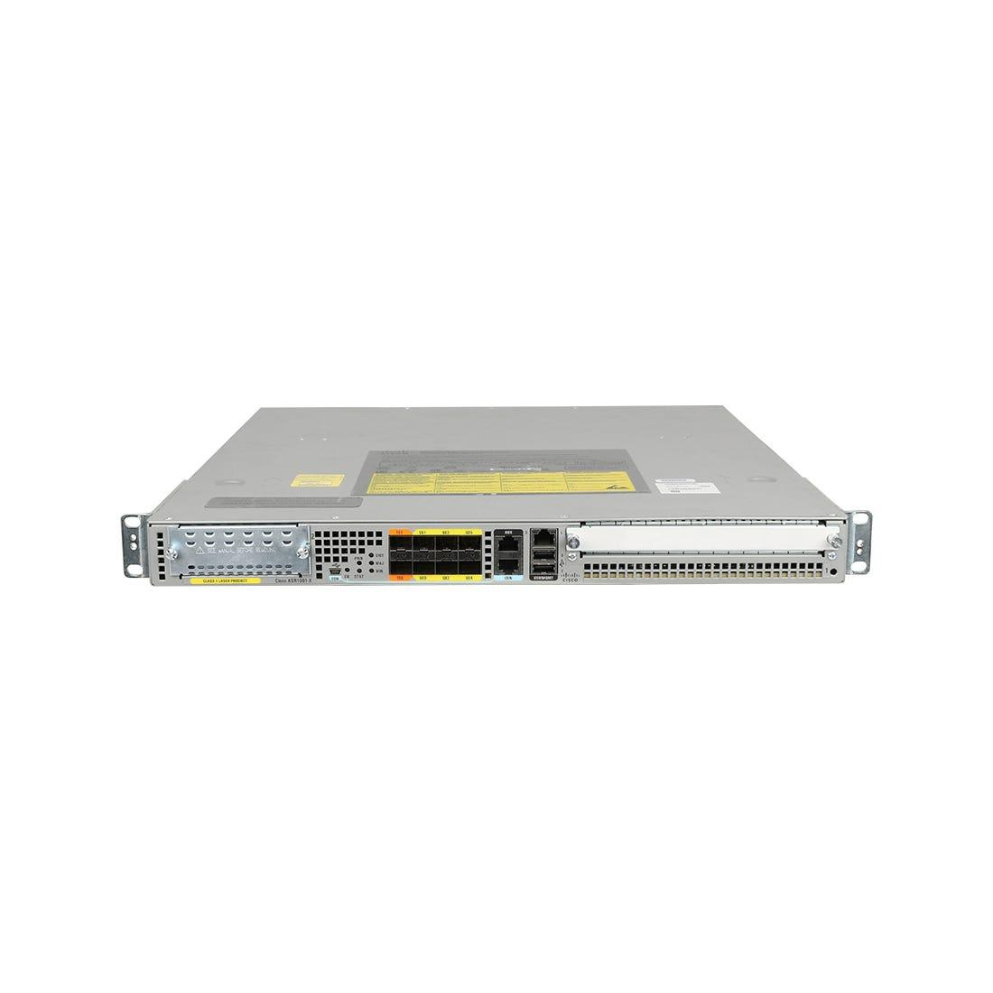
Key features
i. High-speed WAN aggregation: Combines multiple WAN connections and network services, with forwarding capacity ranging from 2.5 to 200 Gbps.
ii. Integrated network services: Supports functions such as encryption and traffic management for enterprise networks.

